Lab Report:

Name: Le Thien Nam Nguyen

NISD: nln157

Student number: 11161522

Class: CME 433 Lab

Lab 1

1. Explain the differences between using case statement and if/else statement

* The main difference between case statement and if/else statement is the trace off between time and space:
  + The case statement is executed in parallel. Therefore, it takes less time to finish but it takes more space or area.
  + The if/else statement is executed in serial. Therefore, the critical path is longer and it takes more time to finish. However, it takes up a small space or area.

⇒ In conclusion, if you want trade space for time, you can choose the case statement. If you want to trace time for space, you can choose the if/else statement.

1. Explain how my design can be optimized for performance, and how it can be optimized for (minimum) size/area.

* My design can be optimized for performance in time and space, which means that I can optimize my design so that the optimized design can run faster and take less time than the original one. I can apply technology mapping, case statement and if/else statement.
* My design can be optimized for (minimum) size/area by switching all case statements to if/else statements.

1. I have included the parity_davio code and testbench in the folder
2. Verify with testbench and pictures

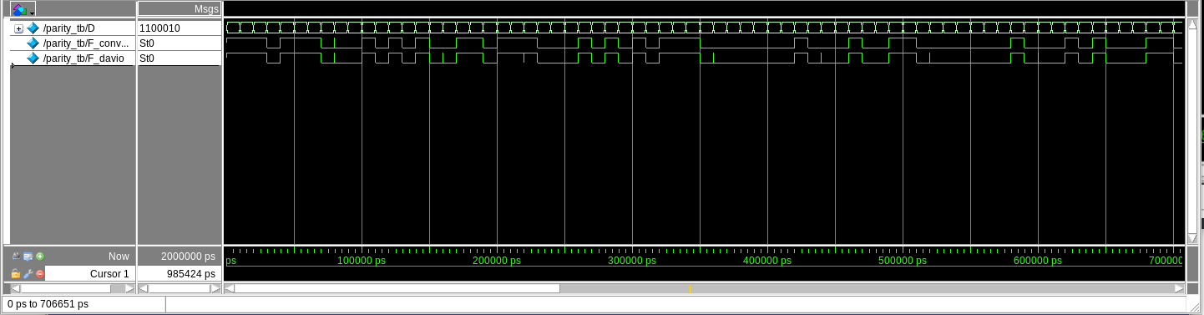

* From the screen shot, we can observe that the waveforms of both convention and davio are identical. These small lines are not values but they indicate the change of inputs.
* I also have an if/else statement to verify the values convention and davio. If they are the same → Verify. If they are different → Error. Here is the result:



1. Optimization strategy

|  |  |  |
| --- | --- | --- |
|  | Davio | Convention |
| Balance | 7 LE | 8 LE |
| Performance | 7 LE | 8 LE |
| Power | 7 LE | 8 LE |
| Area | 7 LE | 8 LE |

* The Davio is better than the Convention with 1 LE. The reason that Balance, Performance, Power and Area are the same is because the Quartus compiler is too advanced. Therefore it makes no difference even though we change the setting.